Carbon Reduction Plan
Supplier name: Cycle Solutions (Cycle to Work) Limited (incorporating Starbill Ltd)
Publication date: 9th September 2026
Version: 3.0

Commitment to achieving Net Zero

Cycle Solutions (Cycle to Work) Limited (and its parent company, Starbill Ltd) is committed to achieving Net Zero emissions by 2050.

Baseline Emissions Footprint

Baseline emissions are a record of the greenhouse gases that have been produced in the past and were produced prior to the introduction of any strategies to reduce emissions. Baseline emissions are the reference point against which emissions reduction can be measured.

Baseline Year: 2021-2022
Additional Details relating to the Baseline Emissions calculations.
Electricity and Natural Gas
Cycle Solutions main use of energy is electricity and natural gas used in buildings across the organisation’s estate. There are 4 buildings across the estate, and these are supplied with electricity and gas via 4no main electricity incomers and 4no main gas incomers. Energy consumption data for electricity and gas was collated from monthly supplier invoices from Eon, Scottish Power and Swalec.
Emissions generated from the burning of natural gas on site are considered Scope 1 (direct combustion), while emissions generated off-site from the provision of grid electricity are considered Scope 2 (indirect energy from generating electricity). Reporting of emissions resulting from the use of grid electricity and natural gas were calculated using the UK Government GHG Conversion Factors for Company Reporting.
Transport Fuel
Cycle Solutions also uses a significant amount of energy for transport fuel. Fuel is used both for business travel in company owned (or hired) vans and cars (Scope 1 direct emissions), or by employees commuting (Scope 3 indirect emissions). Fuel consumption data for business travel was calculated from a combination of staff expenses claims, company fuel card usage, and for miles travelled (using standard £/mile factors).
Fuel expenses figures are converted into energy and carbon by applying average UK diesel cost figures for the year to work out the volume (in litres) of fuel purchased, and then this this figure is converted into carbon using the 2021 UK Government GHG Conversion Factor for kgCO2e/litre (average biofuel blend). The total miles travelled based on mileage expense claims are converted into energy and carbon using the UK Government GHG Conversion Factor for kgCO2e/mile (based on an ‘Executive’ car type). These are then converted into kWh using the kgCO2e/kWh (Gross CV) factor from the UK Government GHG Conversion Factors.

Annual energy consumption and associated carbon emissions for Cycle Solutions over the period September 2021 to August 2022 (the baseline year) are the most recent data.

Where historical Scope 3 emissions have not been measured; estimates are based on guidance that up to 80% of organisations emissions are scope 3 from: PRN_0621_Technical Standard_for_the_Completion_of_Carbon_Reduction_Plans_2.pdf. There are plans to expand our data capture to improve the accuracy of our Scope 3 emissions reporting in future.
Baseline year emissions:
EMISSIONS | TOTAL (tCO₂e)
Scope 1 | 5.94
Scope 2 | 21.89
Scope 3  (Included Sources) | 225.20  Waste generated in operations – 18.90  Business Travel – 0.07  Employee Commuting – 9.55  Upstream & Downstream transportation and distribution (estimated) – 225.20
Total Emissions | 281.55

Current Emissions Reporting
Reporting Year: 2022 - 2023
EMISSIONS | TOTAL (tCO₂e)
Scope 1 | TBC
Scope 2 | TBC
Scope 3  (Included Sources) | TBC
Total Emissions | TBC
Note: current-year emissions data collection is ongoing. Figures for the 2022-2023 reporting year (and subsequent years) will be added to this Carbon Reduction Plan once finalised.

Emissions reduction targets

In order to continue our progress to achieving Net Zero, we have adopted the following carbon reduction targets.

We project that carbon emissions will decrease over the next five years to 253.4 tCO₂e by 2027. This is a reduction of 10%.

Carbon Reduction Projects

Completed Carbon Reduction Initiatives

The following environmental management measures and projects have been completed or implemented since the 2022 baseline.
Most of these focus on:
- Reducing the consumption of electricity and natural gas
- Reducing fuel consumption associated with company travel for external meetings and site visits
- Reducing commuter journeys by car
Facility and Building | Project | Goals
Unit 6 Europa Way | LED lighting upgrade in offices and all common areas | Reduce electricity consumption
Unit 6 Europa Way | Boiler replacement (Workshop and Warehouse) | Reduce gas consumption
Unit 6 Europa Way | Central heating installation | Reduce gas and electricity consumption
Unit 6 Europa Way | Installation of PIR lighting controls | Reduce electricity consumption
Unit 6 Europa Way | Upgrade to shower and locker facilities | Reduce commuter journeys by motor vehicle – and fuel consumption
Unit 6 Europa Way | Introduction of web meetings and online roadshow events | Reduction in company travel
Unit 6 Europa Way | Partial electrification of company fleet vehicles | Reduction in fuel consumption
Unit 10 Europa Way | Installation of PIR lighting controls in warehouse | Reduce electricity consumption
Unit 10 Europa Way | Boiler replacement | Reduce gas consumption
Unit 10 Europa Way | LED lighting upgrade in offices and all common areas | Reduce electricity consumption
Dura Park Bynea | LED lighting upgrade in warehouse | Reduce electricity consumption
Dura Park Bynea | Rooftop PV system | Reduce electricity consumption
Dura Park Bynea | Installation of PIR lighting controls in offices and common areas | Reduce electricity consumption
Unit 6 Europa Way | Further electrification of company fleet vehicles, including introduction of a Mercedes electric van and retirement of 4no. ICE (internal combustion engine) company cars | Reduction in fuel consumption
Unit 10 Europa Way | Upgrade to shower and locker facilities | Reduce commuter journeys by motor vehicle – and fuel consumption
Uprise Bikes Showroom & Service Centre, Unit 2 Kingsway, Fforestfach, Swansea, SA5 4DL | Solar PV installation | Reduce electricity consumption

In the future we hope to implement further measures including:

Facility and Building | Project | Goals
Unit 6 Europa Way | Rooftop PV system | Reduce electricity consumption
Unit 6 Europa Way | Further Installation of PIR lighting controls | Reduce electricity consumption
Cycle Solutions Uplands | Move location to premises with rooftop PV system | Reduce electricity consumption

Further initiatives

As a leading provider of the Cycle to Work scheme our mission is to increase the number of journeys made by bicycle across the UK. In addition to the continued promotion of the Cycle to Work scheme, Cycle Solutions is actively involved in initiatives aimed at increasing cycle usage by businesses and employers, and organisations at a national level.

We will conduct a staff survey on commuting transport methods and days working from home and onsite, with the aim of reducing the number of journeys made to and from the workplace.

Declaration and Sign Off

This Carbon Reduction Plan has been completed in accordance with PPN 06/21 and associated guidance and reporting standard for Carbon Reduction Plans.
Emissions have been reported and recorded in accordance with the published reporting standard for Carbon Reduction Plans and the GHG Reporting Protocol corporate standard and uses the appropriate Government emission conversion factors for greenhouse gas company reporting.
Scope 1 and Scope 2 emissions have been reported in accordance with SECR requirements, and the required subset of Scope 3 emissions have been reported in accordance with the published reporting standard for Carbon Reduction Plans and the Corporate Value Chain (Scope 3) Standard.
This Carbon Reduction Plan has been reviewed and signed off by the board of directors (or equivalent management body).

Signed on behalf of the Supplier:
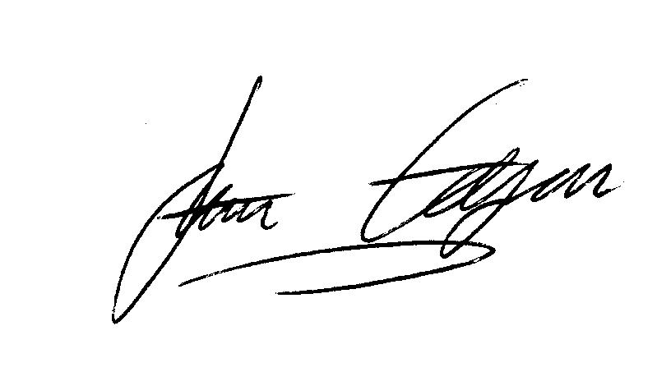
Managing Director
Date: 09 September 2026

https://ghgprotocol.org/corporate-standard
https://www.gov.uk/government/collections/government-conversion-factors-for-company-reporting
https://ghgprotocol.org/standards/scope-3-standard

